# 3rd Testing – 19th of April

Story 6B: Upload a file: Drag and drop

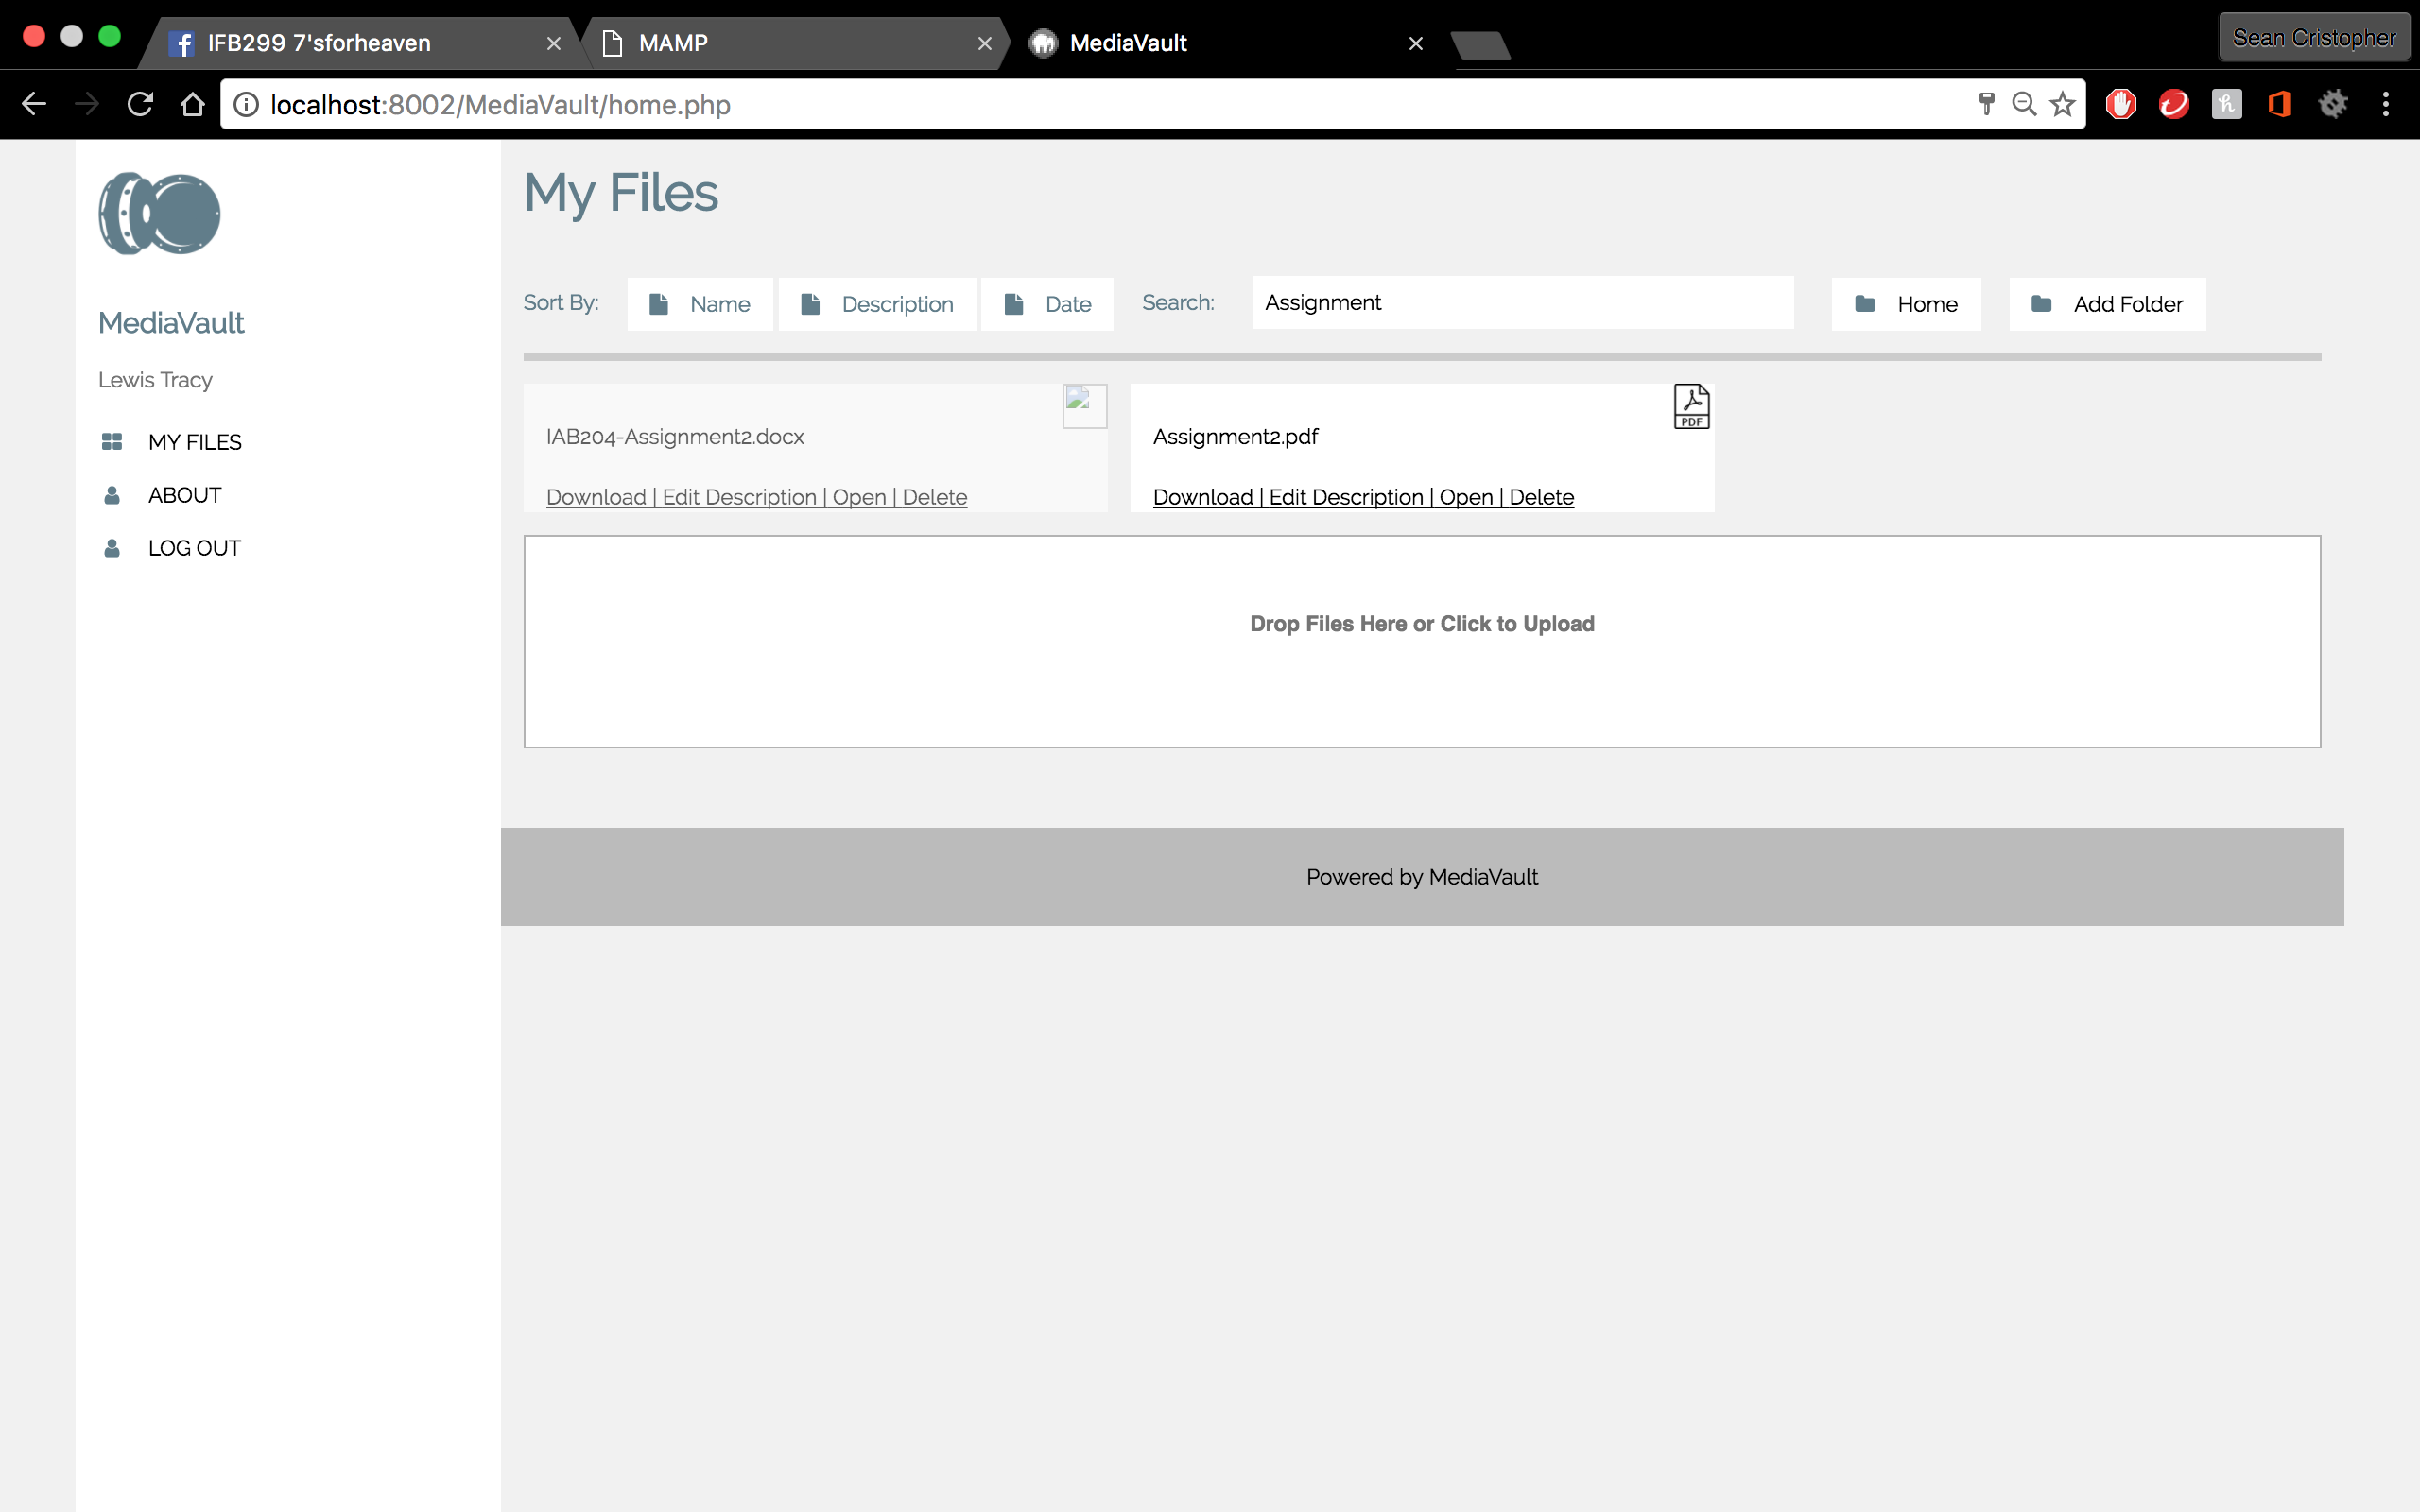 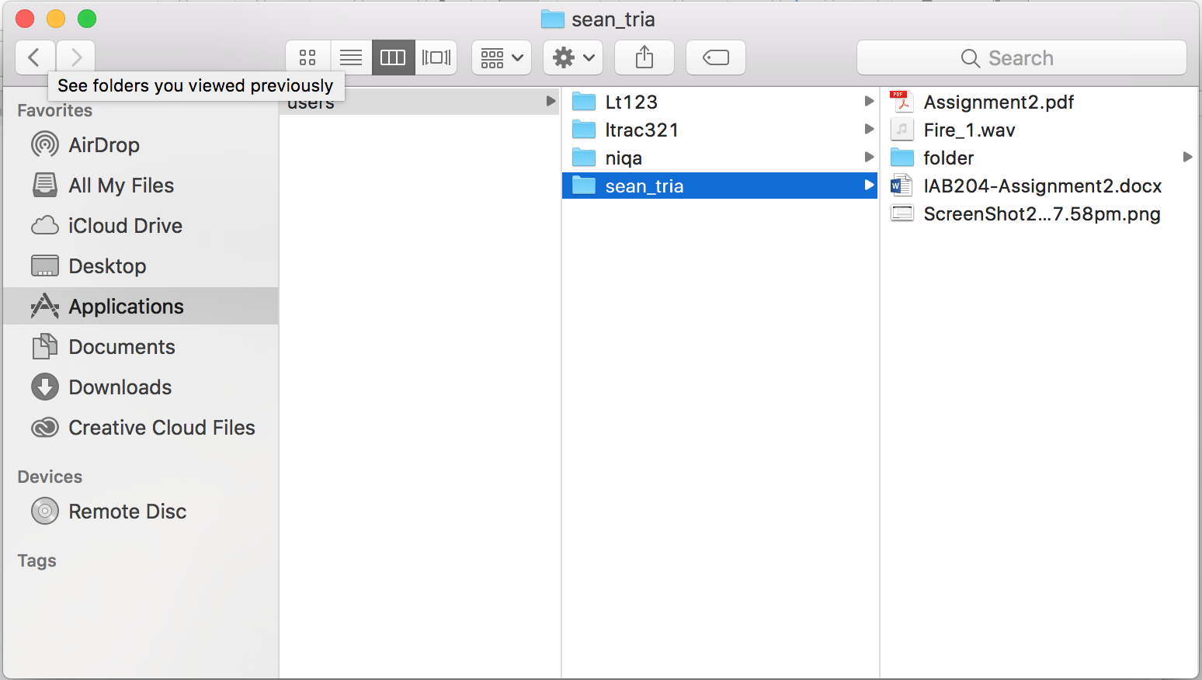

* Empty grid below functions as a layout for drag and drop
* Files successfully uploads to file server just like file explorer

Story 18: View/Edit Account Details

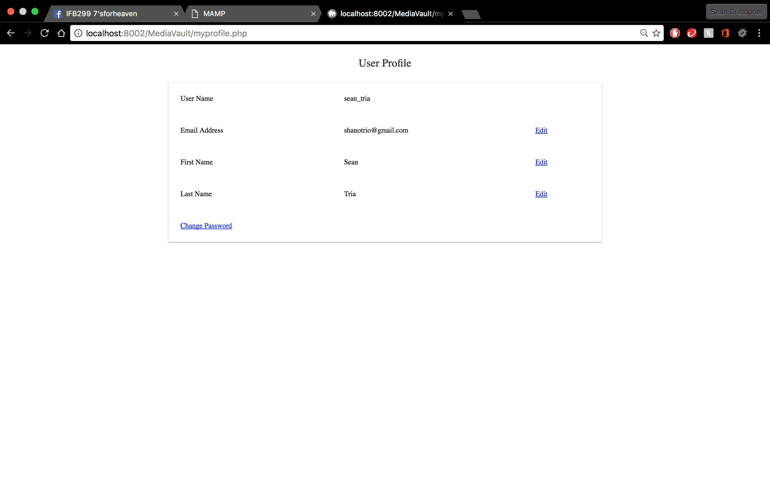

* “About” button functions as view/edit account details
* View and edit account details functions
* Test shows edit dependencies

Story 19: Reset Forgotten Password

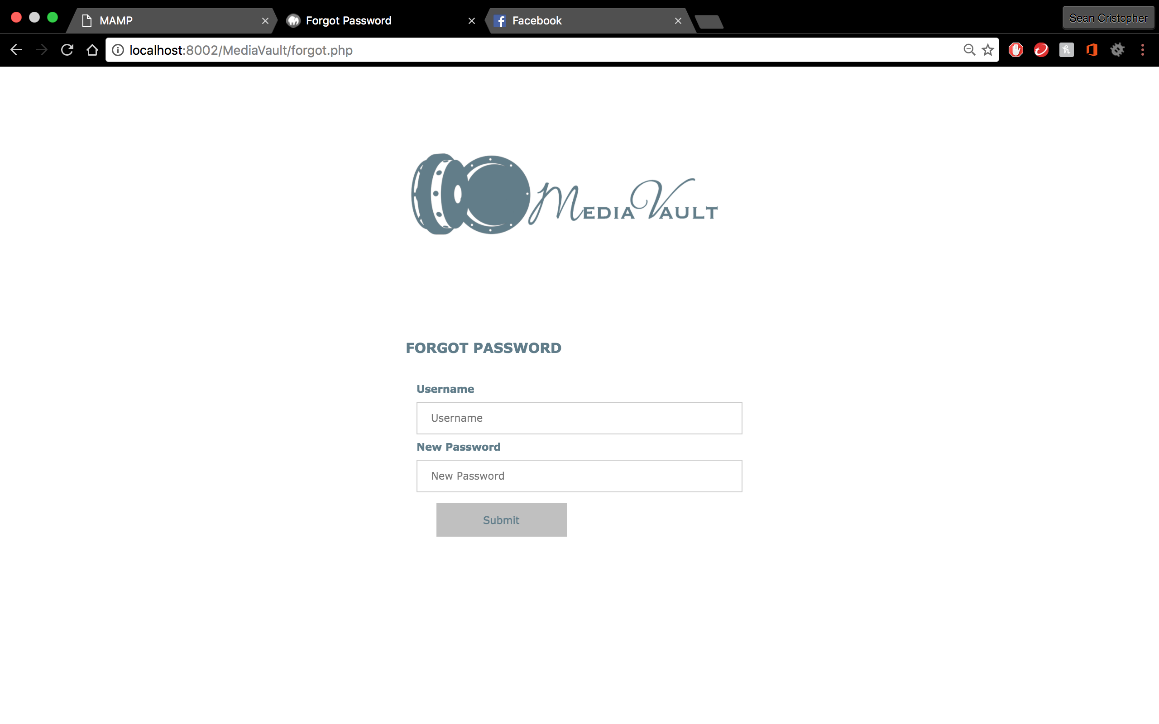

* Tests shows forgotten password functions
* If invalid username is used, correct error pops up
* Verifies authentication

Summary: Testing completed. User stories functions. Drag and drop functions but takes time.